**Last Call**

Send time: Day before the end of campaign

Sender: UWNU CEO/board, or campaign chair first/last name

Subject: Time is running out to Lead the Way

Preheader Text: Changing Our Community Starts with You

Have you donated yet to **Lead the Way** in Northern Utah?

Today is the last day to make your pledge.​ Join **[PARTICIPATION RATE]% of your [COMPANY NAME] co-workers** who are working for lasting solutions to the problems in our community.

Together, we can better the lives of nearly 200,000 struggling children and their families along the Wasatch Front.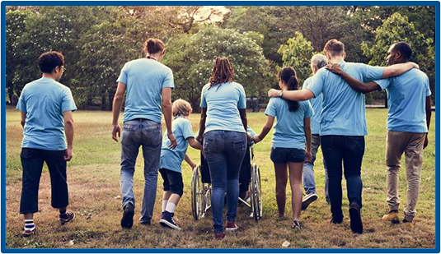

**[PLEDGE/GIVE NOW] - enter link provided by United Way Representative**

Let's all take action in the next 24 hours and help create positive change in our community.

Thank you for everything you do to help lift those most vulnerable. **Together, we can LIVE UNITED.**

Sincerely,

**[SIGNATURE]**