**Last Call**

Send time: Day before the end of campaign

Sender: Workplace campaign coordinator

Subject: LAST CALL: Changing Our Community Starts with You

Dear **[NAME**],

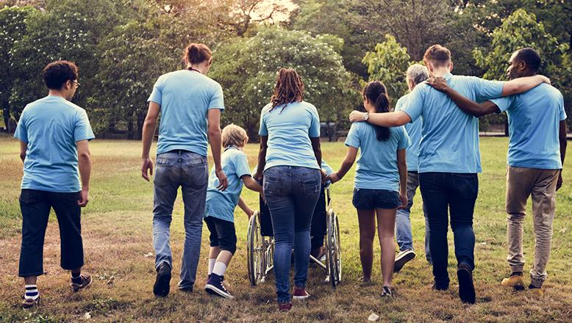

If you’ve been waiting for the right time to join our **Change doesn’t just happen, we create it together** campaign, this is it!

Today is the last day to make your pledge.​ Join **[PARTICIPATION RATE]% of your [COMPANY NAME] co-workers** who are working for lasting solutions to the problems in our community.

Together, we can better the lives of nearly 200,000 struggling children and their families along the Wasatch Front.

**[PLEDGE/GIVE NOW] - enter link provided by United Way Representative**

Let's all take action in the next 24 hours and help create positive change in our community.

Thank you for everything you do to help lift those most vulnerable. **Together, we can LIVE UNITED.**

Sincerely,

**[SIGNATURE]**