Reminder #1 Email
Send time: depending on the length of your campaign, send one reminder email per week.

Sender: United Way CEO, Board, or Campaign Chair first/last name
Subject: What are we doing together in Northern Utah?
Preheader text: Mobilizing our community and changing lives.



Hi [Name],

Change doesn't just happen, We create it together! So we need you with us – whether you’re new to United Way of Northern Utah or you’ve been creating change with us for years.

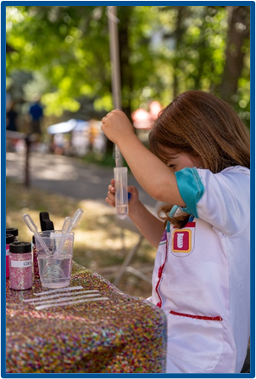
At United Way, we believe that everyone who lives and works in Northern Utah deserves the opportunity to thrive. Together with you and partners like [Company Name], UWNU mobilizes the caring power of people to create transformation change here in Northern Utah.

Day in and day out, United Way of Northern Utah supports and leads programs that meet the most urgent needs in our community. We’re proud of all we’ve accomplished together:
- 224 Welcome Baby families
- 3,226 Student Success students
- 10 Playgroups
- 105 nonprofits served

More work is needed to build this momentum. If you’ve already given, thank you. If you haven’t, there’s still time to join us in Leading the Way to a better future for our community.

[DONATE] - enter link provided by United Way Representative

Sincerely,
[SIGNATURE]

