Campaign Invitation (Launch Day)
SEND TIME: Campaign launch day
SENDER: Company CEO/Leader, of Employee Campaign Chair’s first/last name
SUBJECT: [Company Name] is Leading the Way in Northern Utah


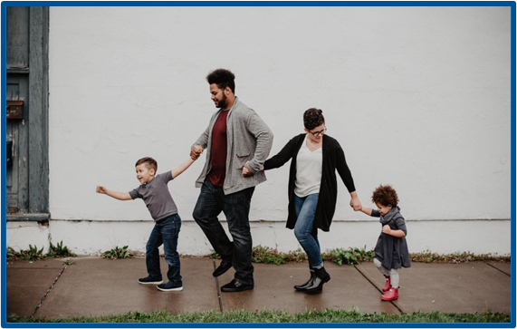
[Name],
United Way of Northern Utah supports the needs of our community every day to help strengthen our community to ensure everyone will thrive. Join me in leading the way to a thriving community by participating in this year’s campaign. We’ve set an ambitious goal of raising [$goal] to help do just that.

I believe that when we come together as a team, there’s no challenge we can’t solve. Please join me in Leading the Way toward positive change in Northern Utah. This is more than a campaign – it’s a call to action for us at [Company Name] to advance solutions to real problems facing people in the communities where we live and work.

By pledging your support, you and your co-workers can help us hit our goal of [Monetary Goal/Description]​. The best part? Your investment stays local and you can see the results in your own community — because education, health, and financial security are not distant issues.

United Way of Northern Utah is seeing results. Last year, with our support, they were able to directly help over 3,500 children through the Welcome Baby, Learn With Playgroup, and Student Success programs. This year, we know we can do even more. And you can be a part of the solution. You can make our community a better place.

[LEAD THE WAY] - enter link provided by United Way Representative

Thank you in advance for joining [Company Name] in Leading the Way, because Change doesn't just happen, We create it together! We are lucky to have YOU!

Sincerely,
[SIGNATURE]

